OUTPUT : (LESS THAN 100CM) - LED GLOWS

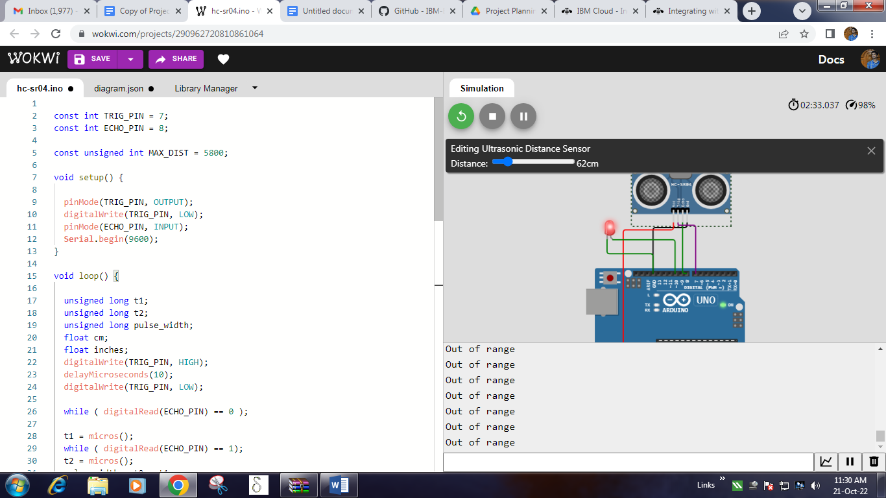

OUTPUT : (MORE THAN 100CM) - LED DOESN'T GLOW

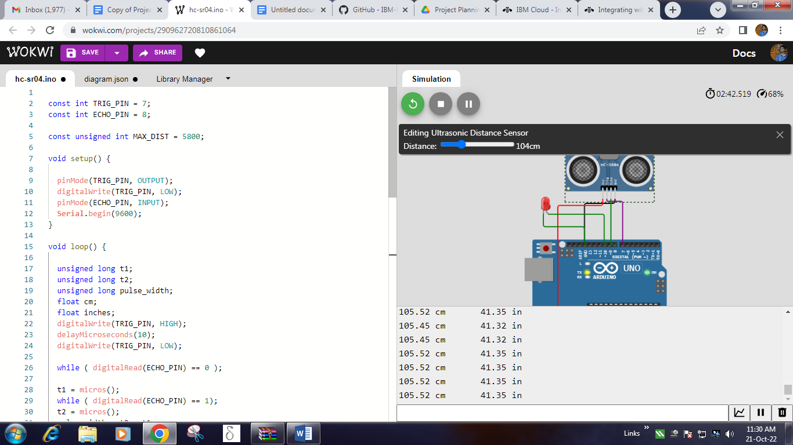

**CODE:**

const int TRIG_PIN = 7;

const int ECHO_PIN = 8;

const unsigned int MAX_DIST = 5800;

void setup() {

pinMode(TRIG_PIN, OUTPUT);

digitalWrite(TRIG_PIN, LOW);

pinMode(ECHO_PIN, INPUT);

**Serial**.begin(9600);

}

void loop() {

unsigned long t1;

unsigned long t2;

unsigned long pulse_width;

float cm;

float inches;

digitalWrite(TRIG_PIN, HIGH);

delayMicroseconds(10);

digitalWrite(TRIG_PIN, LOW);

while ( digitalRead(ECHO_PIN) == 0 );

t1 = micros();

while ( digitalRead(ECHO_PIN) == 1);

t2 = micros();

pulse_width = t2 - t1;

cm = pulse_width / 58.0;

inches = pulse_width / 148.0;

if ( pulse_width < MAX_DIST ) {

**Serial**.println("Out of range");

setup1();

loop1();

} else {

**Serial**.print(cm);

**Serial**.print(" cm \t");

**Serial**.print(inches);

**Serial**.println(" in");

}

delay(60);

}

void setup1() {

pinMode(10, OUTPUT); }

void loop1() {

digitalWrite(10, HIGH); delay(500);

digitalWrite(10, LOW);

delay(500);

}